BRISBANE TOWNSVILLE

EMPLOYEE DETAILS
Name: |  |  |  | Date of Birth:
Address:
Home Phone: |  | Mobile: |  | Occupation:
Date Employed: |  |  |  | Sex: | Female Male
Employment: | Full time employee Part time employee Casual Employee Volunteer

First aid injury Medical Treatment Injury Lost Time Injury Near Miss
Property Damage Government Notifiable Event Notification only

INCIDENT DETAILS
Date of Incident: |  | Time of Incident:
Date reported to Spinal Injuries Association: |  | Who was it first reported to:
Client Name  (if applicable): |  | Client Address  (if applicable):
On duty On duty and in motor vehicle accident On a work break
Travelling to or from work Other. Please specify:

What was the actual job being performed when the incident occurred?
Describe what actually happened?
Was this activity part of your normal routine? If not, please explain the circumstances which required this activity to be undertaken.
Did anyone witness the incident? (Please provide name, address and telephone number). | Name:_______________________________  Address:_____________________________  ____________________________________  Telephone Number:____________________ | Name:_______________________________  Address:_____________________________  ____________________________________  Telephone Number:____________________

INJURY OUTCOME
Injury/Illness Description: |  | FRONT VIEW  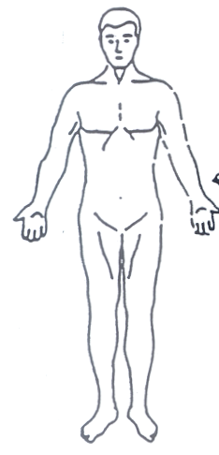  Right Left | BACK VIEW  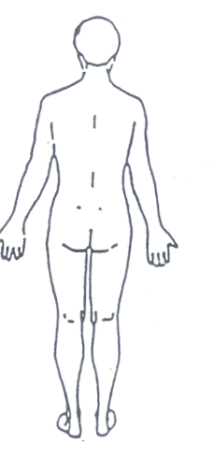  Left Right
Did you require any medical attention for your injury? | Nil  First aid only  Doctor consulted  Hospital  Name:__________________
Workers Compensation Form required? | Yes No
Did you continue to work after the incident? | Yes No

EQUIPMENT BEING USED (if involved in incident)
Type: |  | Model/Make:
Was the equipment in good working order? | Yes No Details:______________________________________

PERSONAL PROTECTIVE EQUIPMENT (PPE)
Should PPE (eg. gloves) have been worn for the task being undertaken? | Yes No
Was it being worn/used? | Yes No
Was it available? | Yes No
Type of PPE required? | Details:__________________

WORKER’S DECLARATION - I declare the above information is correct and not misleading
WORKER’S Name | Signature | Date
_______________________________________ | __________________________ | ________

INCIDENT INVESTIGATION to be completed by the person investigating
What were the main contributing factors?
RISK  ASSESSMENT |  | Consequences  1. Insignificant 2. Minor 3. Moderate 4. Major 5. Catastrophic |  | Risk Score  (Likelihood +  Consequences  scores)
Likelihood
1. Rare 2. Unlikely 3. Possible 4. Likely 5. Almost Certain
Type of Incident  Slips/trips/falls  Repetitive action  Hitting an object  Manual Handling  (Body Stressing)  Other_______________ |  | Abrasion/Bruise  Cuts/sharps  Heat/temperature  Mental stress  Electricity  ______________________________ | Cause of Incident  Equipment/plant  Vehicle  Client/human factors  Tools/Static equipment  (e.g. computer)  Other_________________ | Environment  Hazardous substances  Live animals  Bodily Fluids  _________________________

CORRECTIVE/PREVENTATIVE ACTIONS
Proposed | Responsibility | Proposed Date | Actual  Date

COMMENTS on implementing the corrective/preventative actions recommended above

VALIDATION The undersigned have investigated this incident and do state this information is the best available information according to the known facts.
Investigator (Manager - Workplace Health & Safety) | Signature | Date
Supervisor | Signature | Date
Manager | Signature | Date

